|  |  |
| --- | --- |
| **Team Id** | **PNT2022TMID46546** |
| **Project Name** | **Hazardous area monitoring for industrial plant powered by IOT** |
|  |  |
|  |  |
|  |  |
|  |  |

**Node red flow created to get values**

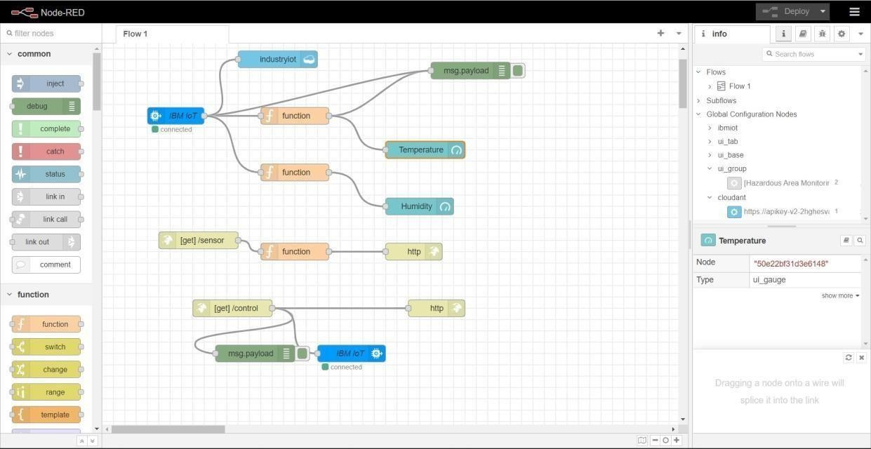

**Configuring function to fetch the desired value**

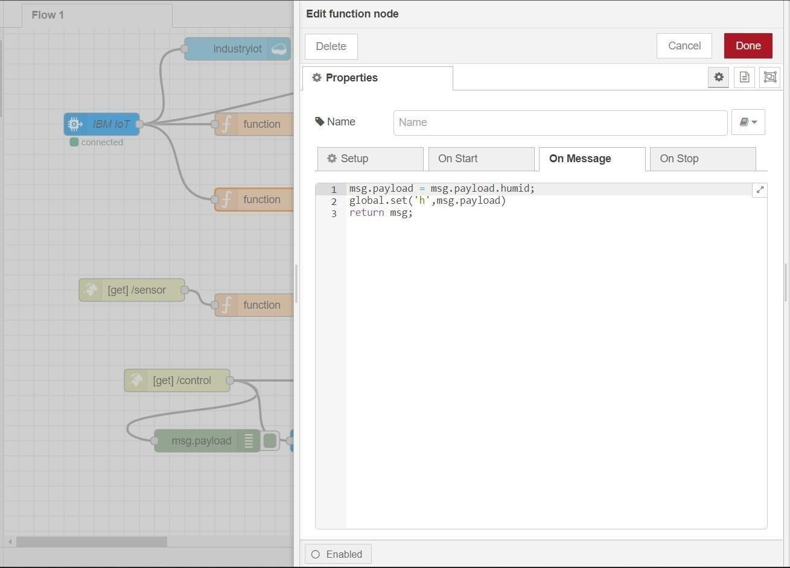

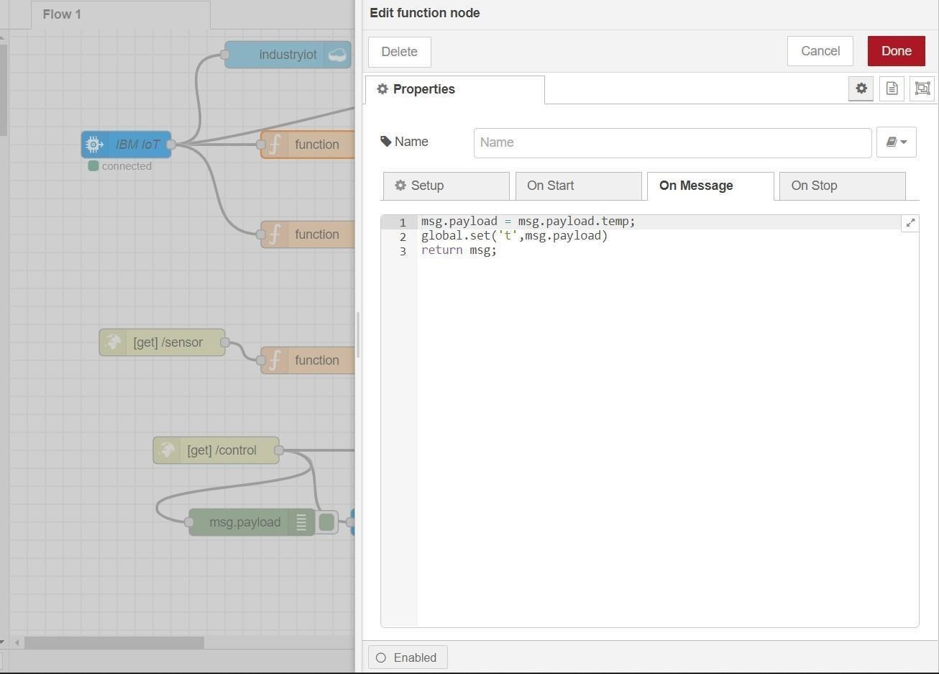

**App Blocks to render the values and display it in app**

